**IoT Competition using Raspberry Pi**

Intel IoT Club, Amrita Vishwa Vidyapeetham

Date: August 19, 2023 (Saturday) – 10 AM to 4 PM

Event: Online

***Group No – 4***

***Team Member:***

1. G.S.S.Nikhil – CB.EN.U4CSE21121
2. K.Madhu – CB.EN.U4CSE21128
3. N.Surya – CB.EN.U4CSE21138
4. P.Sudheekar – CB.EN.U4CSE21142

***Title:*** Smart Agriculture Monitoring and Control System

***Abstract:***

The "Smart Agriculture Monitoring and Control System" is an IoT application that harnesses the capabilities of the Grove Pi Kit sensors to optimize agricultural practices. By utilizing all available sensors, this system aims to improve crop yield, resource utilization, and environmental sustainability through real-time monitoring and automated control of key agricultural parameters.

***Introduction:***

The Smart Agriculture Monitoring and Control System leverages IoT technology to transform traditional farming into a smart and efficient process. By integrating a variety of sensors from the Grove Pi Kit, this application enhances crop production, resource management, and sustainability.

***Hardware Required:***

1. Raspberry Pi 3

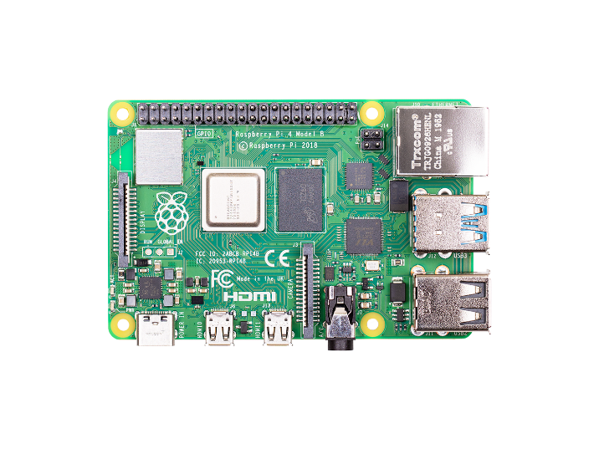

1. Grove Pi Sensors

* 1)LED’s
* 2)Sound Sensor
* 3)Temperature and Humidity Sensor
* 4)Light Sensor
* 5)Relay
* 6)Button
* 7)Ultra Sonic
* 8)Rotatory Sensor
* 9)Buzzer
* 10)Color LCD Display

***Purpose of each sensor:***

1. 3 LEDs (Red, Blue, Green): Indicators for system status and alerts.

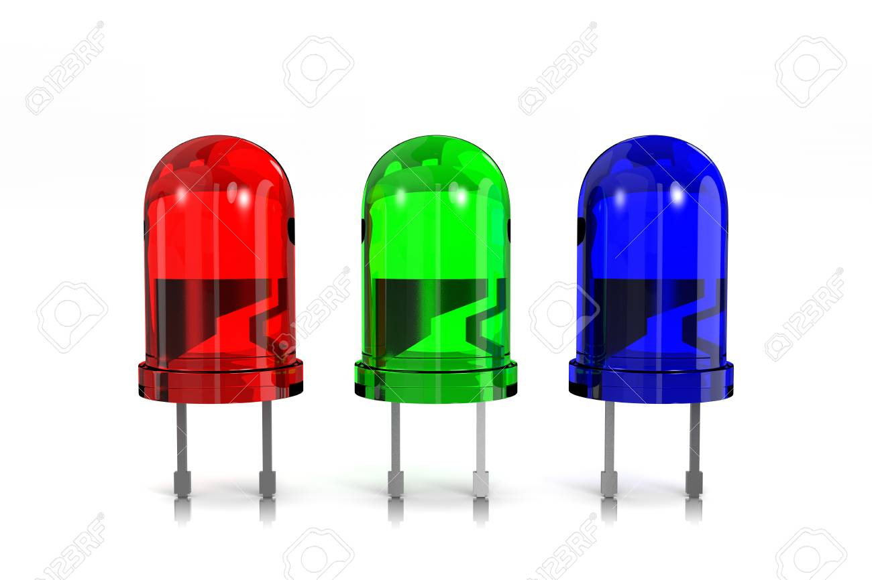

2. Sound Sensor: Detects pest or animal activity and sends notifications.

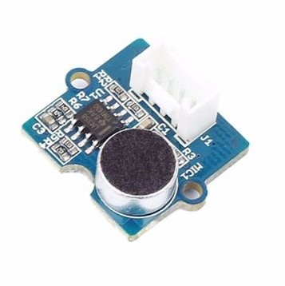

3. Temperature and Humidity Sensor: Monitors microclimates in different parts of the field.

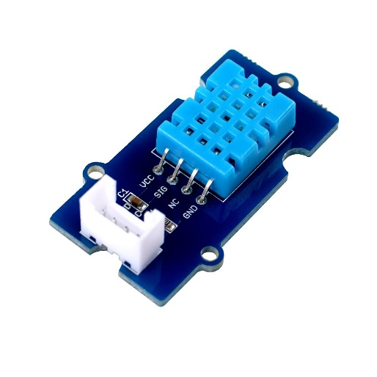

4. Light Sensor: Measures sunlight intensity for optimal crop growth.

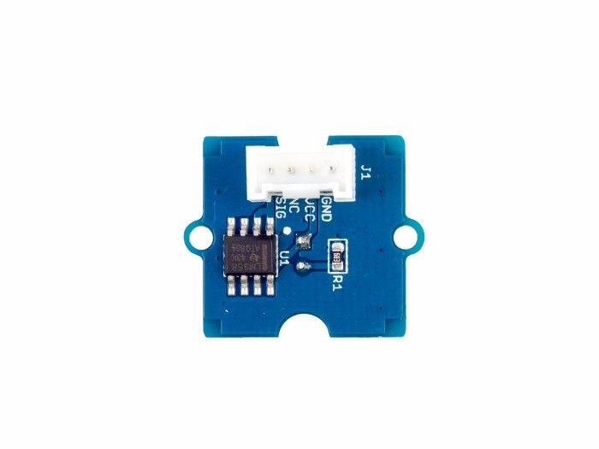

5. Relay: Controls irrigation systems, pumps, and other devices.

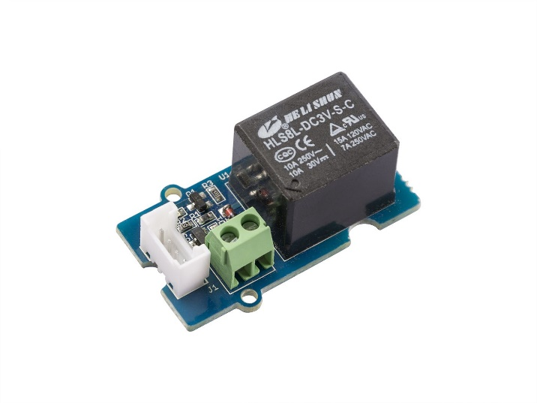

6. Button: Provides manual input for specific actions or overrides.

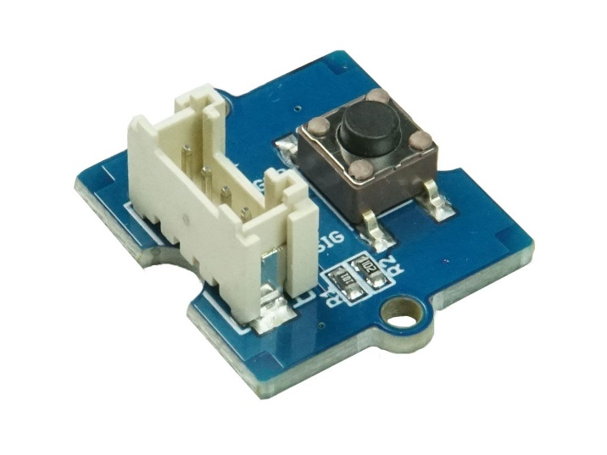

7. Ultrasonic Sensor: Measures soil moisture levels to optimize irrigation.



8. Rotary Sensor: Adjusts settings like irrigation frequency or fan speed.

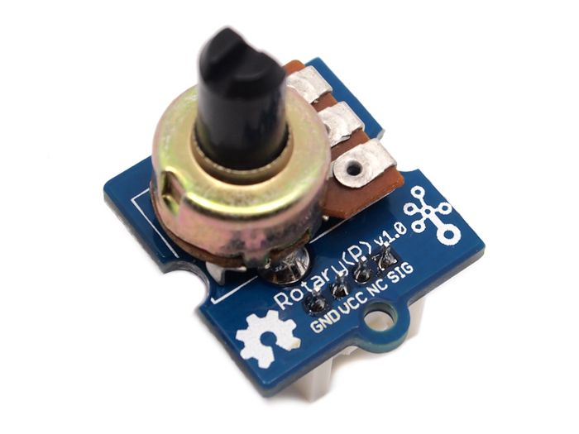

9. Buzzer: Provides audio alerts for critical events.



10. Color LCD Display: Displays real-time data and system information.

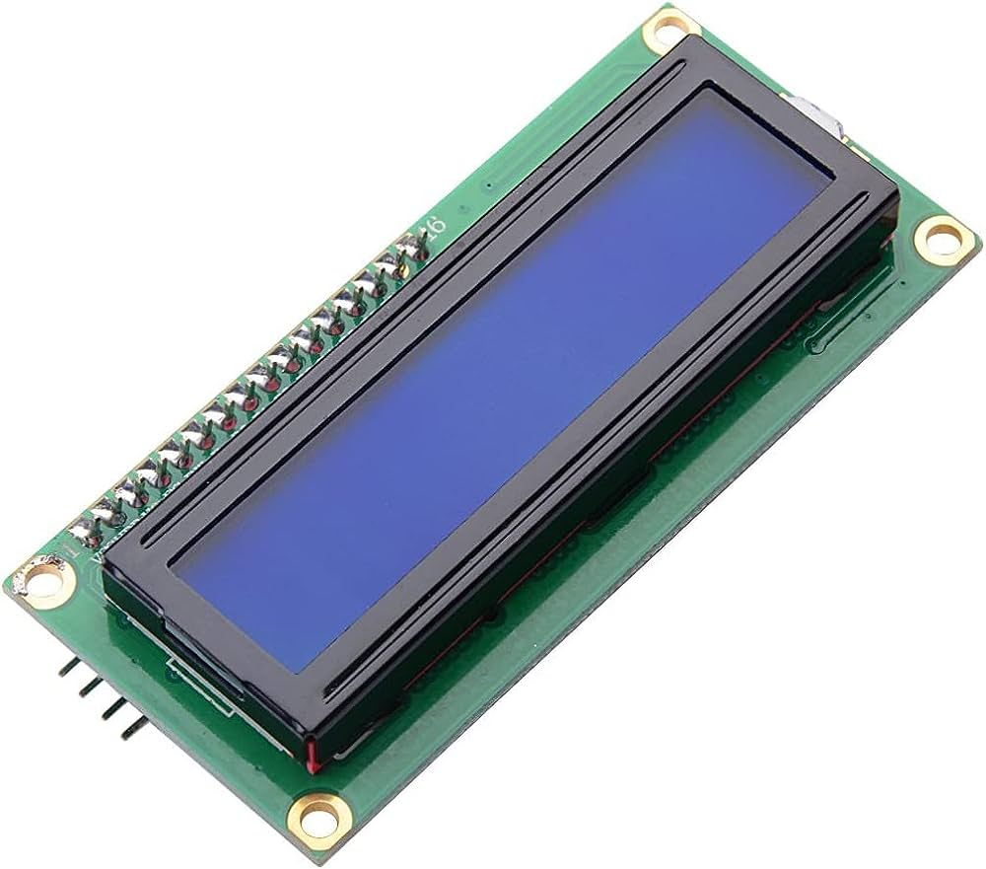

***Schematic diagram:***

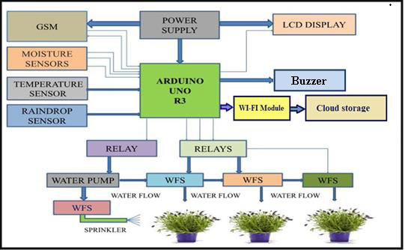

***Application: Smart Agriculture Monitoring and Control System:***

The IoT application utilizes the Grove Pi Kit sensors to create a comprehensive smart agriculture solution with the following functionalities:

- Precision Irrigation: The Temperature and Humidity Sensor, along with the Ultrasonic Sensor, measures soil moisture and environmental conditions, enabling efficient irrigation control based on real-time data.

- Crop Growth Optimization: The Light Sensor monitors sunlight levels, helping farmers make informed decisions on crop placement and timing.

- Pest and Animal Detection: The Sound Sensor detects unusual sounds, alerting farmers to potential pest or animal activity.

- Remote Monitoring: The Button and Color LCD Display provide a user-friendly interface for manual control and status updates.

- Resource Management: The Relay controls irrigation systems and other devices, conserving water and energy resources.

- Flexibility: The Rotary Sensor allows farmers to adjust parameters to suit different crops and changing conditions.

- Early Warning System: The Buzzer provides audio alerts for critical conditions such as extreme temperature or low soil moisture.

- Data-Driven Decisions: The system collects and analyzes data, enabling farmers to make informed decisions to enhance yield and reduce waste.

***CODE:***

*import grovepi*

*from grove_rgb_lcd import \**

*import time*

*# Set up sensor pins*

*led_pins = [4, 3, 2] # Red, Blue, Green LEDs*

*sound_sensor = 0*

*temp_hum_sensor = 7*

*light_sensor = 1*

*relay_pin = 8*

*button_pin = 6*

*ultrasonic_sensor = 2*

*rotary_sensor = 14*

*buzzer_pin = 5*

*# Initialize sensor connections*

*for led_pin in led_pins:*

*grovepi.pinMode(led_pin, "OUTPUT")*

*grovepi.pinMode(sound_sensor, "INPUT")*

*grovepi.pinMode(temp_hum_sensor, "INPUT")*

*grovepi.pinMode(light_sensor, "INPUT")*

*grovepi.pinMode(relay_pin, "OUTPUT")*

*grovepi.pinMode(button_pin, "INPUT")*

*grovepi.pinMode(ultrasonic_sensor, "INPUT")*

*grovepi.pinMode(rotary_sensor, "INPUT")*

*grovepi.pinMode(buzzer_pin, "OUTPUT")*

*# Initialize LCD*

*setRGB(0, 128, 64)*

*setText("Initializing...")*

*try:*

*while True:*

*# Sound sensor*

*sound_value = grovepi.analogRead(sound_sensor)*

*if sound_value > 300:*

*digitalWrite(led_pins[0], 1) # Turn on the red LED*

*setText("Sound detected")*

*grovepi.digitalWrite(buzzer_pin, 1)*

*else:*

*digitalWrite(led_pins[0], 0)*

*grovepi.digitalWrite(buzzer_pin, 0)*

*# Temperature and humidity sensor*

*[temp, humidity] = grovepi.dht(temp_hum_sensor, 0)*

*setText(f"Temp: {temp:.1f}C Humidity: {humidity:.1f}%")*

*# Light sensor*

*light_value = grovepi.analogRead(light_sensor)*

*if light_value < 300:*

*digitalWrite(led_pins[2], 1) # Turn on the green LED*

*else:*

*digitalWrite(led_pins[2], 0)*

*# Ultrasonic sensor*

*distance = grovepi.ultrasonicRead(ultrasonic_sensor)*

*setText(f"Distance: {distance} cm")*

*# Button*

*button_state = grovepi.digitalRead(button_pin)*

*if button_state == 1:*

*digitalWrite(led_pins[1], 1) # Turn on the blue LED*

*else:*

*digitalWrite(led_pins[1], 0)*

*# Rotary sensor*

*rotary_value = grovepi.analogRead(rotary_sensor)*

*setText(f"Rotary: {rotary_value}")*

*time.sleep(0.5)*

*except KeyboardInterrupt:*

*digitalWrite(relay_pin, 0) # Turn off relay*

*for led_pin in led_pins:*

*digitalWrite(led_pin, 0)*

*grovepi.digitalWrite(buzzer_pin, 0)*

*setText("Goodbye!")*

***Conclusion:***

The Smart Agriculture Monitoring and Control System showcases the potential of the Grove Pi Kit sensors in revolutionizing farming practices. By merging these sensors with a Raspberry Pi, the application offers real-time monitoring, automation, and informed decision-making for agricultural processes. This system contributes to improved crop yield, resource efficiency, and sustainable farming practices, addressing challenges in modern agriculture and promoting environmentally friendly approaches.